How to print to MFD with Paper Cut Smart card

Introduction
Because your multifunction device (MFD) has account tracking enabled, you must authenticate with scanning your Card or Username and password on every computer you wish to use. This is profile driven so every user must complete the following. (However it only needs to be done once per user)

Adding your printer:
1: Press search and type devices and printer.
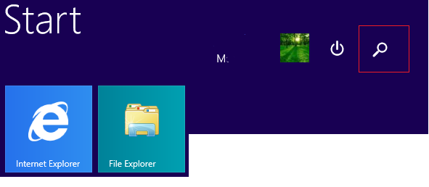
2: Press Devices and Printers
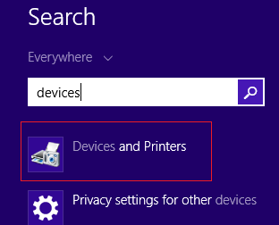
3: New window will appear, Click Add a printer.

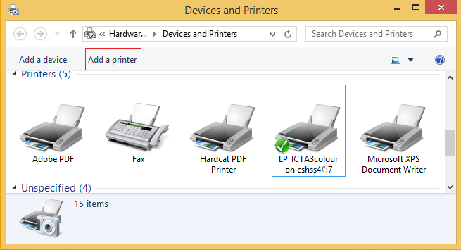
4: Select the one of the following.
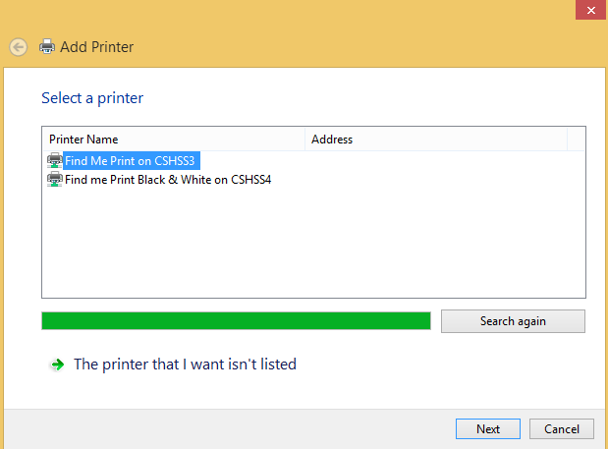
5: Then press next, it will install the driver. Press next again and finish.

Configuring the Paper Cut Swipe Card:
1: If you don’t have the swipe card please get a card from Arlene Thomas. You can also use Smart Rider as the swipe card. This will not charge from your smart riders Balance. It’s will use just for the authentication purpose.
2: please swipe the card on the card reader attached with MFD.
3: MFD will ask you to use your user name and password.
4: Please enter your schools User name and Password.
5: it will register the card.
6: Now you can print jobs to the attached printer from your computer (Find me Print / find me print Black & White). To get print out please scan your card to any of the MFD’s and release the job.
7: Contact ICT if you need help with the printing.

