- Using a web browser. (EDGE, Google Chrome, Firefox etc.)

If you have sync issues with your notebooks in OneNote 365 application, you can always use the web browser to view the class notebook and complete work using this method. To access the web browser version of OneNote students can either:

1. Proceed to the Churchlands website and click on the Office 365 icon under the student quick links. This is on the top right of the webpage.
2. Login using the school credentials and once logged in, click on the OneNote icon on the left-hand side of the page. Here you will find all the notebooks that have been shared to you by teachers.

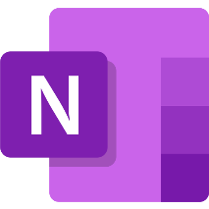

2. Using OneNote 365 application

This is the current version of OneNote and is the recommended way to view Class Notebooks.
If you have Sync Issues with this version of OneNote it is recommended that you open OneNote, click on the Username in the top right hand corner and check this is a Churchlands username and e-mail. If it is not a Churchlands username, try signing out and signing in using your Churchlands account.

If you still have sync issues:
1. Type Access work or school into the windows search bar and click on it.
2. If you have a Churchlands account listed in here click on it and click disconnect.
3. Open OneNote, click on sign in with a different account, put in Churchlands email, username and password, untick allow organization to manage my device and follow the prompts.

3. Using the OneNote for Windows 10 application

Please be aware that this version has been discontinued and as such we recommend using the other ways to view your notebooks.

